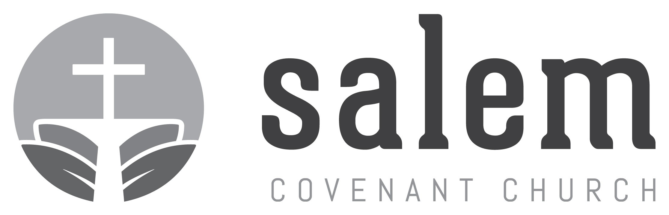
GO:2018 Missions Application Form

Please use this form to apply for any of Salem’s GO:2018 mission trips. Remember to include a check for the trip deposit as directed by your trip leader. Final trip expenses must be submitted by the due date set by each trip leader.
Return the completed form to the Outreach Director, Shelli Streeper (sstreeper@salem-covenant.church), by March 1, 2018.

GO:2018 Mission Participant

Name
Are you a Salem member/attender? Address

Cell phone
Email
Birthday
Occupation
Tshirt Size

Additional Family Members and birthdate, if applicable
Name
Name
Name
Name
Name

Which GO:2018 Mission Trip(s) are you registering for?
Alaska Czech Republic CMMBC, Virginia

Emergency Contact Name and Phone Number

Name Relationship Phone

Special Considerations (allergies, physical limitations, dietary needs/requirements)

Tell us briefly about your faith story and why you are interested in participating in a GO: 2018 Mission Trip.

I understand that I personally assume all risks and responsibilities in connection with my [and family’s] participation in this mission trip and release Salem Covenant Church, and its representatives, of any injury to self (and family members) or damage to property which may occur during participation. For international mission trips, each individual participant is responsible for acquiring their own travel insurance.
The undersigned below has agreed to these statements:

Signature Date
Deposit Rec'd
Finalized
FOR OFFICE USE ONLY
Deposit
Application

